Enhancing Data Accuracy Through Data Cleaning Techniques

`INTRODUCTION
This project focuses on data cleaning and pre processing using Microsoft Excel. The data-set was analyzed to identify missing values, duplicate records, formatting inconsistencies, and data entry errors. Various Excel features and functions were used to clean, organize, and standardize the data. The objective of this project is to improve data accuracy, consistency, and quality, making the data-set ready for further analysis and decision-making.

DATASET DESCRIPTION

The data-set contains the following column.
COLUMN NAME | DESCRIPTION
MANUFACTURING DATE | Products manufacturing date.
COUNTY CODE | Products country code.
PRODUCT BRAND | Products and Brand name.
PRICE | Price of the Products.
QUANTITY | Quantity of the Products.
CATEGORY | Products category

- Identified and handled missing values in the data-set.
- Removed duplicate records to improve data accuracy.
- Corrected typos and inconsistencies in text fields.
- Standardized data formats such as dates, currency, and text.
- Split and merged columns where required for better data organization.
- Applied conditional formatting to highlight important data patterns.
- Converted data types to ensure consistency across the data-set.
- Created new columns using formulas and transformations.
- Improved overall data quality and reliability.
- Prepared the data-set for efficient analysis and reporting.

Data Cleaning Process

Handling Missing Values
Removing Duplicates
Correcting Errors and Typos
Standardizing Data Formats

Data Transformation Process

Splitting Columns
Merging Columns
Data Type Conversion
Creating New Columns

Tools and Functions Used

Find and Replace
Remove Duplicates
Conditional Formatting
Text to Columns
IF Function
AVERAGE Function
Format Cells (Date & Currency Formatting)

RESULTS AND OUTCOME

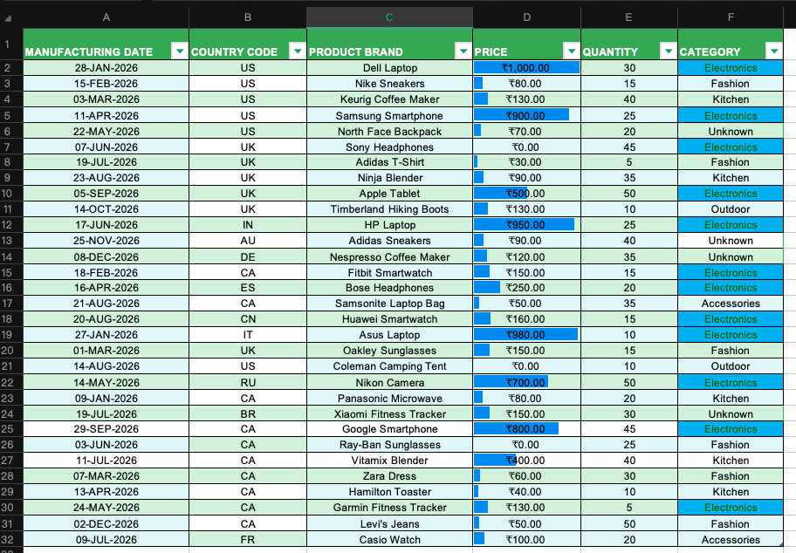
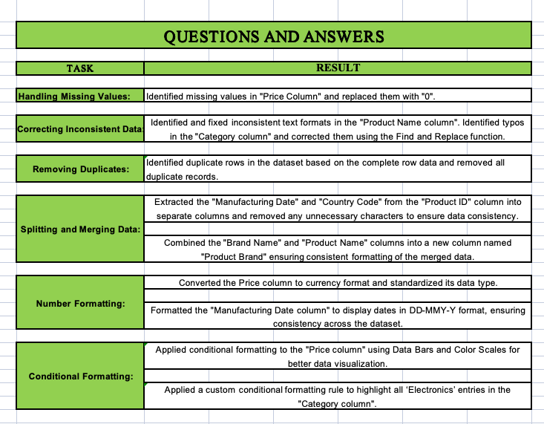

CONCLUSION
In this assignment, I worked on a data-set and applied various data analysis techniques. I used data cleaning methods such as handling missing values, removing duplicates, and correcting data types. I also performed data transformation like merging columns and formatting date and price fields. For analysis, I used descriptive analysis techniques and applied Excel functions and formulas for calculations. In addition, I used conditional formatting like data bars, color scales, and custom rules to highlight important insights. Overall, this assignment helped me understand data preprocessing, analysis, and visualization using Excel, and improved my practical data handling skills.

